Membership Application
(PLEASE PRINT CLEARLY – All "Required Fields" (*) must be completed)

Last Name (*): ___________________________ First Name (*): __________________
Address (*): ____________________________________________________________
City (*): ________________________________ State (*):_______ Zip (*):__________
Home Phone (*): ______________________ Cell Phone: ______________________
Email Address: ____________________________________________________
(FOR CLUB UPDATES AND MONTHLY NEWSLETTERS ONLY)
Auto Make / Model (*): _________________________________________________
License Plate State / Number (*): ________________________________________

 | Membership Type | Rate
◻ | Field | $160 | Family is not included.
◻ | Family | $190 | Includes spouse and children under 21 in the same household.
◻ | Student / Military | $50 | Proof of full-time Enrollment in High School / Military
◻ | Active | $25 | There are 3 requirements to achieve this level:  [1] Nominated & voted upon by Officers  [2] Active field member for one year  [3] Member in “good” standings with at least 4 hours per month work party participation

IMPORTANT NOTES:
Please submit a completed form with cash or check to a Club Officer at a scheduled shoot or monthly meeting. Times and dates are published on the website. Members can also call/text Vaughn Adams(484-390-1270) or Chris McFadden(267-481-1889) to make other arrangements.

Your signature is required here ________________________________________. Providing your signature as the applicant identified above, verifies that you have read and understand the “General Rules & Regulations” attached to this application.
_________________________________________________________________
Club Use:
Date: ____________________ | Cash / Check # _________ | Card | Key

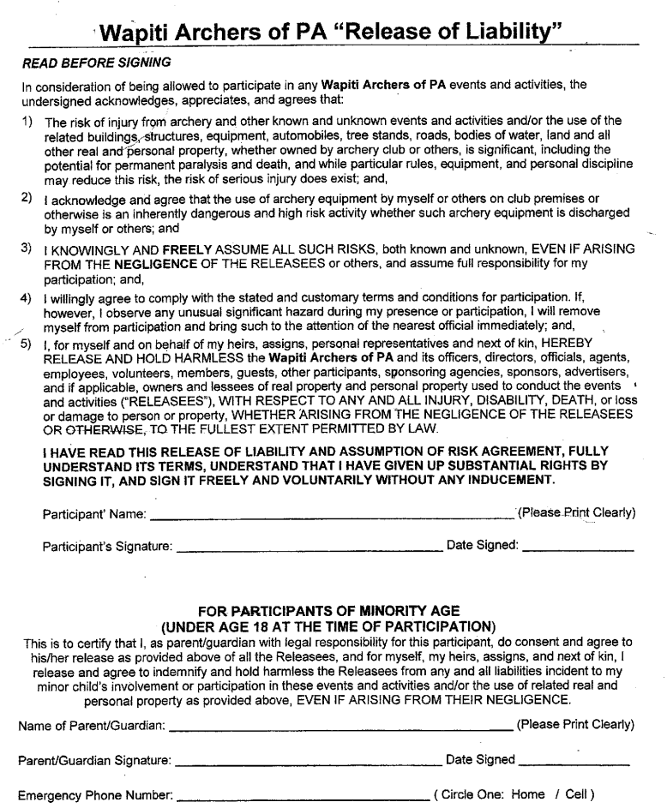GENERAL RULES & REGULATIONS

- No Alcoholic Beverages are permitted on the premises. - The land is owned by the PA State Park. All PA Department of Conservation & Natural Resources rules and regulations are in effect and enforced in accordance with those posted on the website http://www.dcnr.state.pa.us/stateparks/. A copy of these rules and regulations will be available for viewing by all members / participants at the club house.

- Membership Cards must be worn and visible at all times when on the club premises. - It is your right and responsibility as a Member to police the club premises. The Membership Card is official proof that a person belongs on the grounds. If a person is found on the property not wearing a membership card, politely request him or her to produce the card while in your presence or leave the property. If there is resistance to your request, take their vehicle’s license plate number and report it to the Secretary as soon as possible.

- No Guests are not permitted. - Members are encouraged to bring guests to an Open Shoot. Times, dates and guest rates are published on the website.

- All Family Members, 15 years old and under, entering the premises under a “Family Membership”, must be accompanied by an adult.

- All memberships and access keys are valid until the first Sunday in February of the following year.

- The use of personal stands, climbers or saddles is prohibited. – Shooting platforms are available for practicing from an elevated position.

- Hunting is not permitted on the premises. ***

- Cross Bows are not permitted to be used anywhere at Wapiti. ***

- NO Broad Heads are permitted on the 3D Courses. *** - Broad Heads are permitted to be shot in the quarry at targets designed for broad heads and set up in the designated area.

*** - Any violation of these rules will result in immediate termination of membership

If you have any questions about this application, please contact
Vaughn Adams (Secretary/Memberships) at 484-390-1270.

